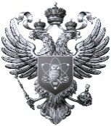

|  |  |
| --- | --- |
| MINISTRY OF SCIENCE AND HIGHER EDUCATION  OF THE RUSSIAN FEDERATION  **Federal State Autonomous**  **Educational Institution**  **of Higher Education**  **«Murmansk Arctic University»**  **(MAU)**  Sportivnaya St. 13, Murmansk, 183010  Tel./fax: +7 (8152) 21-38-01 / 45-27-52  Email: [office@mauniver.ru](mailto:office@mauniver.ru)  <http://www.mauniver.ru>  OKPO 00471633, OGRN 1025100848651  INN / KPP 5190100176 / 519001001  ______________ № ______________  To № _________ from ____________ |  |